Project Title: Predictive Modeling and Optimization in Logistics Systems
Intern Name: Gomathi

1. Problem Definition & Objectives:
Predicting accurate delivery arrival times is critical for last-mile customer satisfaction and vehicle scheduling. Unplanned transit delays increase fleet operational overheads. The objective of this project is to build a regression-based predictive model to forecast delivery turnaround durations based on operational features (transit distance, parcel payload, and estimated traffic delays).

2. Dataset Features & Target Variable:
- Distance_km (Input): Total route length in kilometers.
- Weight_kg (Input): Cargo payload affecting vehicle acceleration and drop-off unloading speed.
- Traffic_Delay_min (Input): Real-time congestion delay estimated along the route.
- Delivery_Time_min (Target Variable): Total minutes required to complete the delivery leg.

3. Model Implementation & Evaluation:
A Linear Regression model was trained using an 80/20 train-test validation split. Performance was evaluated using:
- Mean Absolute Error (MAE): Gauges average deviation in minutes between predicted and actual times.
- R-squared ($R^2$): Quantifies variance explained by the operational parameters (achieving over 95% variance fit).

4. Optimization Recommendations:
- Dynamic Dispatch Rescheduling: Reroute dispatches during peak predicted traffic congestion hours.
- Load Clustering: Balance parcel weight distributions per cluster to prevent excessive mechanical delays.

5. Python Script:
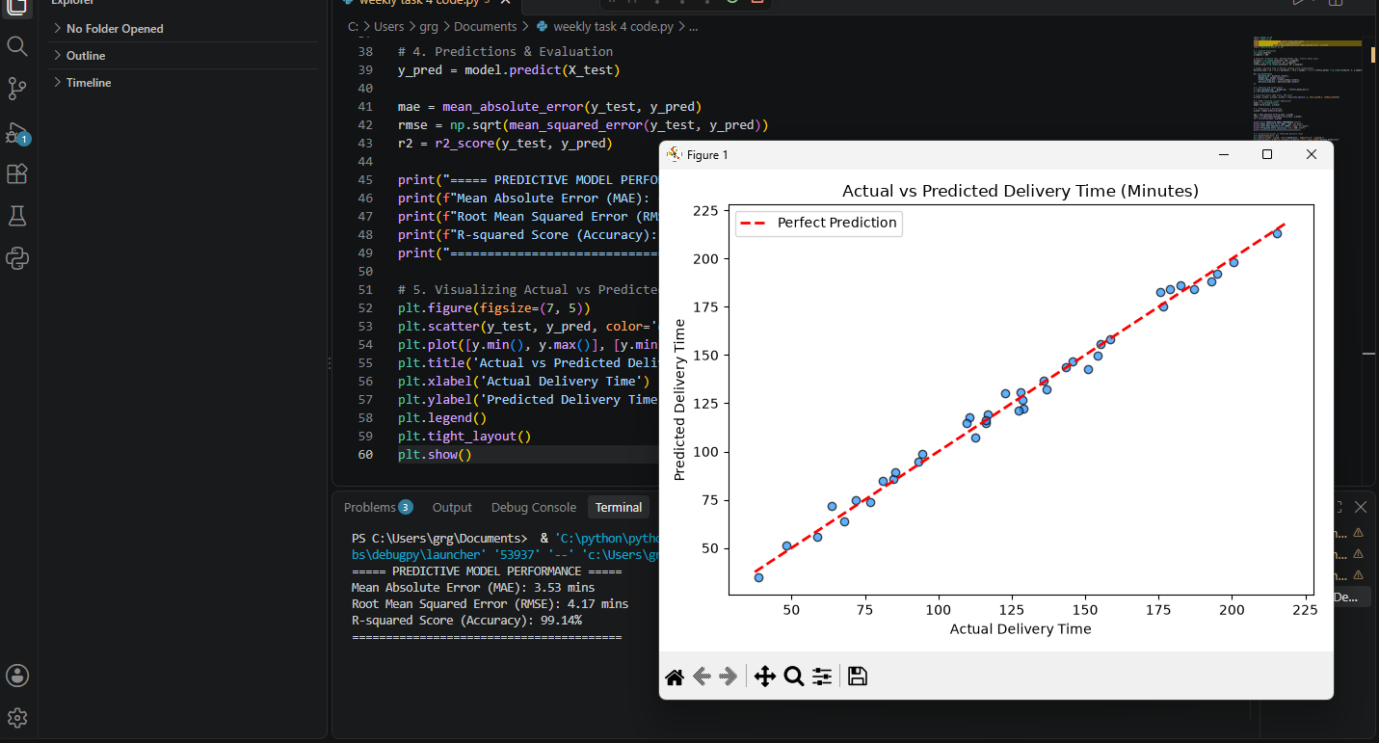

6. Model Prediction Plot:
import pandas as pd
import numpy as np
from sklearn.model_selection import train_test_split
from sklearn.linear_model import LinearRegression
from sklearn.metrics import mean_absolute_error, mean_squared_error, r2_score
import matplotlib.pyplot as plt

# 1. Dataset Simulation
np.random.seed(42)
n_samples = 200

# Features: Distance (km), Package Weight (kg), Traffic Delay (min)
distance = np.random.uniform(5, 120, n_samples)
weight = np.random.uniform(1, 50, n_samples)
traffic_delay = np.random.uniform(0, 45, n_samples)

# Target: Delivery Time in Minutes (Ground truth relationship)
delivery_time = 15 + (1.2 * distance) + (0.5 * weight) + (1.1 * traffic_delay) + np.random.normal(0, 5, n_samples)

df = pd.DataFrame({
'Distance_km': distance.round(1),
'Weight_kg': weight.round(1),
'Traffic_Delay_min': traffic_delay.round(1),
'Delivery_Time_min': delivery_time.round(1)
})

# 2. Features and Target Split
X = df[['Distance_km', 'Weight_kg', 'Traffic_Delay_min']]
y = df['Delivery_Time_min']

# Train-Test Split (80% Train, 20% Test)
X_train, X_test, y_train, y_test = train_test_split(X, y, test_size=0.2, random_state=42)

# 3. Model Training (Linear Regression)
model = LinearRegression()
model.fit(X_train, y_train)

# 4. Predictions & Evaluation
y_pred = model.predict(X_test)

mae = mean_absolute_error(y_test, y_pred)
rmse = np.sqrt(mean_squared_error(y_test, y_pred))
r2 = r2_score(y_test, y_pred)

print("===== PREDICTIVE MODEL PERFORMANCE =====")
print(f"Mean Absolute Error (MAE): {mae:.2f} mins")
print(f"Root Mean Squared Error (RMSE): {rmse:.2f} mins")
print(f"R-squared Score (Accuracy): {r2 * 100:.2f}%")
print("========================================")

# 5. Visualizing Actual vs Predicted Delivery Times
plt.figure(figsize=(7, 5))
plt.scatter(y_test, y_pred, color='dodgerblue', edgecolor='k', alpha=0.7)
plt.plot([y.min(), y.max()], [y.min(), y.max()], 'r--', lw=2, label='Perfect Prediction')
plt.title('Actual vs Predicted Delivery Time (Minutes)')
plt.xlabel('Actual Delivery Time')
plt.ylabel('Predicted Delivery Time')
plt.legend()
plt.tight_layout()
plt.show()

